# Device:

The TV box washing machine has been the staple of entertainment and is considered a family member in many homes. However, especially disturbing is a device made to be switched on and off can make this very process sometimes an impossible task; and given mankind’s blessing with memory that of a goldfish makes finding the remote an Indiana Jones Trilogy. While scouring the couches for long lost treasure in search for the remote; the LG’s TV power button became a tempting alternative. Also, this became a source of many human computer interaction principal violations.

# Universal Principals**:**

Visibility

First rule of interface design violation is the disappearance of what is universally considered a power button on a TV. Usually this a round shape with a protruded feel or touch sensor in the corner of the screen. What operated a touch power button was the automatic control that regulates the TV’s screen brightness. The TV’s Power button was hidden in plain sight masquerading as a visually beautiful hollow LED ring; that showed different colours depending on its operational state.

Conceptual Models:

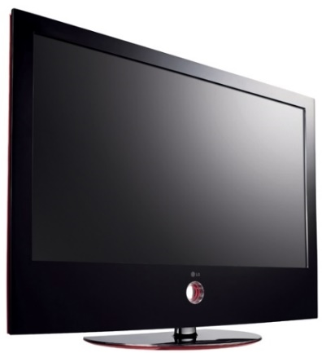

Affordance:

The major violation of human computer interaction design was the ring that seemed like it was exclusively for aesthetics. There was no indication that this circle powered the TV. Also, its appearance did not afford the act of swiping the ring. Instead, it was thought by means of sorcery the TV turned on by passing our finger through the ring rather than a touch sensor.

Constraints

In the instance of losing the whereabouts of the remote; after exploring every inch of the TV, its glowing ring drew us to interact with it. By absolute luck we stumbled upon this very notion that a light shaped in the form of a sphere serves two purposes. This was to look mesmerising and act as a power switch. Also, the physical constraints to localise means of operating the TV was non-existent. there was no regulation procedure to control what constituted a swipe or a touch. There could have been instances where we simultaneous turned the computer on and off.

Mappings

After successfully locating the seemingly unmissable power switch, understanding its nature of powering on the TV was however, a labyrinth of scientific deductions. This TV failed to adequately map the difference of action from inaction. The dim red light turned green when the ring was swiped, however a brightly lit room made the LED indicator almost visually indistinguishable. Also, the standardized I/O symbol to signify a power switch was missing. In anticipation, we waited anxiously for the TV to finally shine its light of moving imagery. Naturally our reaction to the delayed response was to swipe the ring so many times that friction posed a fire hazard.

Feedback

Besides the vague LED lights, by default, there was no sound cues to provide feedback for performing the action of powering the TV. So, to avoid the state of confusion, the natural response is to repeat this process till there is an outcome.

Solution**:**

Apart from the array of human computer interaction issues clouding this TV. Manufacturers can alleviate many of these symptoms simply by mapping the logically universal I/O symbol just beneath the power ring. This will reduce time wastage and help guide the user in first instance of operation. More so, to enhance the feedback of the TV, they can increase the brightness of Sensory LED lights, and add a brief opening tune when its turned on. In the universe of major TV manufacturers, the absence of these somewhat negligible tweaks now could echo heavily against LGs market share in the future.